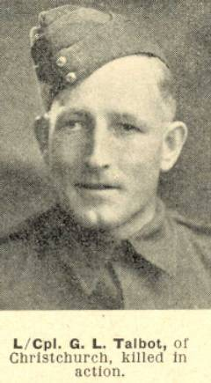
George Logan Talbot
FULL NAME George Logan Talbot
RANK LAST HELD Corporal
FORENAME(S) George Logan
SURNAME Talbot
WAR World War II, 1939-1945
SERIAL NO. 48118
GENDER Male
FIRST KNOWN RANK Private
OCCUPATION BEFORE Store clerk
ENLISTMENT
NEXT TO KIN Mr H.N. Talbot (father), 67
Knowles Street,
Christchurch, New Zealand
MARITAL STATUS Single
ENLISTMENT ADDRESS Public Works Department,
Methven, Canterbury,
New Zealand
MILITARY DISTRICT Waiouru
BODY OF EMBARKATION Second New Zealand Expeditionary
Force (2NZEF)
EMBARKATION UNIT Infantry Brigade
NOMINAL ROLL NUMBER WW2 5
PAGE ON NOMINAL ROLL WW2 205
CAMPAIGNS Italy
LAST UNIT SERVED 20 Armoured Regiment
PLACE OF DEATH Italy
DATE OF DEATH 15 December 1943
AGE AT DEATH 36
YEAR OF DEATH 1943
CAUSE OF DEATH Killed in action
CEMETERY NAME Sangro River War Cemetery, Italy
GRAVE REFERENCE IX. D. 14.
BIOGRAPHICAL NOTES George Talbot son of Horace Norman and Elizabeth Stevenson
Talbot, of Christchurch, Canterbury, New Zealand.

