Disneyland here we come!

(Expensive option)
Virgin Australia
Flights:
Children x3: $1,705 (each)
Adults x2: $1,705 (each)
Total: $8,525
Departure time: 1:00pm
Duration of flight: 21 Hours 10 Minutes
Disneyland tickets:
(Daily)
Children x3: $90x3
Adults x2: 96x2
$462x3
Total: $1,386
Accommodation:
Family of 5: $984
¼ km from DL
Peacock suites
Free wifi breakfast included
Overall total:
NZL: $10,895
US: $8,992

(Cheap option)
Air New Zealand
Flights:
Children x3: $1,055 (each)
Adults x2: $1,055 (each)
Total: $5,275
Departure time: 11:30pm
Duration of flight: 18 Hours 10 Minutes
Disneyland tickets:
(Package deal)
Children x3: $645
Adults x2: $452
Total: $1,097
Accommodation:
Family of 5: $950
½ km from DL
Hyatt place resort and convention centre
Overall total:
NZL: $7,277
US: $5,956

Activities:

2: Grand tour of Los Angeles
Prices:
Package deal: $380
Total:
NZL: $463
US: $380
1: Universal studios
Transport: rental car
Prices:
Children: $63x3
Adults: $70x2
Total: NZL: $401 US: $329

Airport transfers (return): US: $305 NZL: $372
1 day transport: Avis rental car $75 + $50 petrol US: $125 NZL: $152
Food: $200 budget per day = $1,000 for one week US: $1,000 NZL: $1224
Wants: $100 spending money each = $500 in total US: $500 NZL: $612
Passports: Children x3: $245 Adults x2: $280 US: $628 NZL: $770
Travel insurance: $584 (NZL)
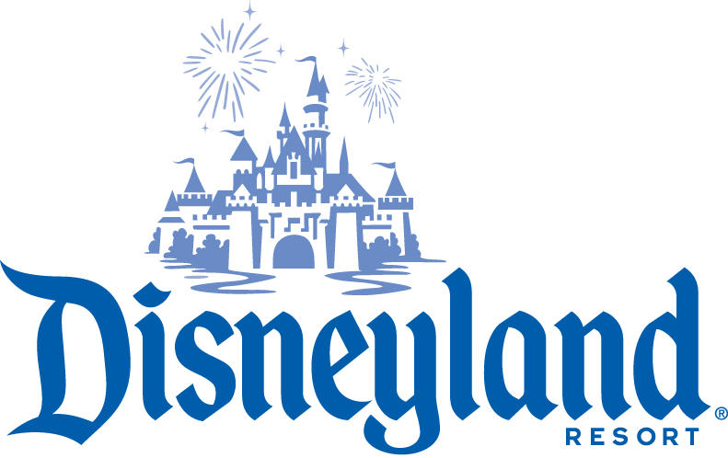
Overall total: NZL: $3,714 US: $2,558
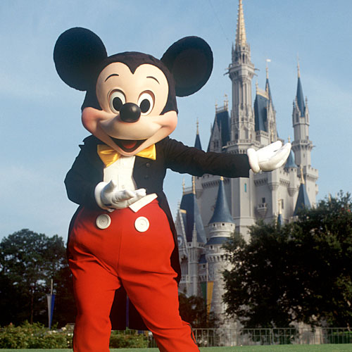
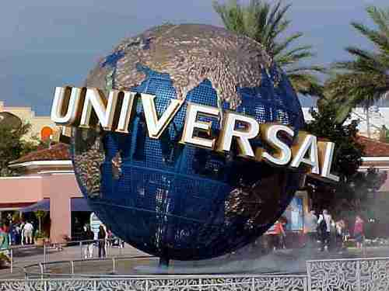
By Sam Taylor

