**Books: ‘Stand Up Speak Up!’ $45 & ‘I’d Rather Swim with Sharks’ $25, plus Postage (& in Aust GST)**

**To Order Email**: [marcelle@marcellebernard.com](mailto:marcelle@marcellebernard.com) with “Order Form Request” in the Subject line.

Marcelle Bernard’s SPEAK EASY session & follow up exercises.

**PREPARE - BEFORE YOU START WRITING YOUR SPEECH**

Purpose – How will you help your audience by giving your speech?

To ENTERTAIN them: - use funny stories, good mannered jokes & humour.

To INSPIRE or PERSUADE them: - use personal stories & loads of enthusiasm.

To NARRATE for them: - be very expressive & create interest.

To EDUCATE them: - use facts, figures & give example. Show credibility & limit jargon.

Audience - How many? What ages, education, cultures & interests.

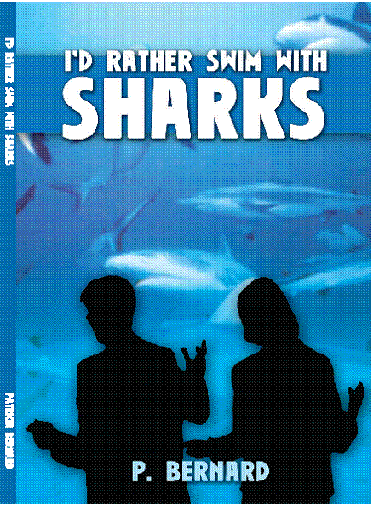Venue - Where are you going to speak? Can you use props or displays? Do you need equipment?

Timing - How long? Can you shorten or lengthen speech? Will you have a question time?

**ACTUAL WRITING**

Material - Your TOPIC is what you generally want to talk about. e.g. pets.

- The FOCUS is what you specifically want to talk about. e.g. My Dog

**– Brainstorm your topic/focus. Add stories, quotes or some humour.**

Language - A speech is spoken so use short words and short sentences.

Use lots of active & descriptive words. e.g. Run, Jump. e.g. Instead of 'The Cat' use 'The fat lazy purring tabby' or 'The sleek aggressive snarling Tom cat'

**STRUCTURE - SPEECH RECIPE** General Topic: _______ Specific Focus: _______ Speech Title: _________

**Opening** Grab Audience Attention (A noise, movement, question, statement, quote or funny story)

Greet the audience (Formal or Informal)

Timing, Topic & Focus (Explain your Topic, focus & how long you will talk for)

3 point preview (Say what you are going to cover in one sentence only)

Why you are the expert. (Why they should listen to you)

How they will benefit. (Why they should listen)

**Body** 3 main points

1) W.W.W.W.W.H. - Who, What, When, Where, Why & How.

e.g. A description. An explanation of the rules or a process or an item.

2) P. P. F. - Past, Present, Future.

e.g. A famous instance, example or personal story.

3) P. R. E. P. - Make Point, give Reason & Example, repeat Point.

e.g. A point of view. An opinion. A debate

**Conclusion** 3 point Summary. (Say what you have said in one sentence only.)

Action call (What you want the audience to do because they listened to you.)

Conclusion (What you think.)

**PRESENTING – Act like a Super Speaker.**

Hands by your sides, shoulders back, chin up, smile, eyes looking at your audience!

Appearance - Is your appearance suitable to your speech & audience? Relax, stand comfortably & confidently.

Visuals - Are you going to use notes, props or a white board.

Body language - Does it add to your speech?

**Say** & **SHOW** what you mean - Length, Age, Shape, Distance, Direction, Activity, Size, & Feelings.

Voice - Vary the rate, volume, pitch, tone, speak clearly. Add emotions & sound effects.

**PRACTICE** Write your speech out in full. Read your speech out loud 10 times. (Tape your voice) Write out your Palm/Cue Cards using bullet points. Practice in front of a mirror 5 times. (Video yourself)

Practice in front of small audiences a) with notes or cue cards. b) without notes or cue cards.

Practice using your High Low Soft Loud Fast & Slow voice. Practice while walking fast. (Get your heart pounding)

**Communication Awareness Exercises**

1. Chinese whispers - A message is whispered from student to student around the room.

This exercise shows what you say is often not what people hear.

2. Have one student explain a complex scene or picture to the rest. Have the other students draw their interpretations of what is being described. This exercise emphasizes the fact that people will interpret the same words in many different ways.

3. Have students divide into groups of 5. They must each write down 10 words they associate with the subject given. Then have their spokesperson list any word all 5 have on their lists. The chances are that less than 3 words will appear on the spokesperson list. The exercise illustrates that we all interpret simple words very differently. This affects communication.

**Impromptu Speaking Exercises**

1. 'Introduce yourself & say .......... ' - what your favourite colour is & why or something fun that happened to you yesterday or something that makes you angry etc This exercise may be used to begin each lesson. It allows students to practice impromptu speaking.

2. Have students interview the student next to them, then introduce their neighbour.

3. Continuous story telling. The leader begins a story, eg " It was a really hot day and the…". The next student adds to the story. The emphasis is on the continuation of a logical story line.

4. Use the formulas below to speak for one minute on any topic given

1) without any time to prepare, 2) with five minutes preparation..

a) Past, Present, Future. Use any single word topic.

b) Point, Reason, Example, Point. Use topics that draw out opinions or thoughts.

c) What, When, Where, Why, Who, Why? Use topics that require a lot of explanation.

**Using Visuals** Have students use the black board or flip chart to explain ideas with pictures. (Use pointers)

Give students various items & ask them to explain its use or attempt to sell them to the rest of the group.

**Body Language** Use body language to show the following:

LENGTH, short, long, tall, short. COMPARISON, same, different. AGE, young, old.

SHAPE - round, square, triangle. DISTANCE, far, near, DIRECTION, there, here,

ACTIVITY , golf, softball, net ball, marbles, strength, aggression SIZE, small, huge.

FEELINGS like aggression, shyness, happiness, sadness.

Have students divide into groups & write a story which involves as much body language as possible. Have one of them read the group's story out while another group of students performs the body language.

**Voice** Use voice to show - EMOTIONS - anger, fear, happiness, comfort, secrets, urgency.

1. Have students read short pieces of writing that lend themselves well to expressing emotion with their voices.

2. Have students recite popular nursery rhymes in a variety of roles. eg Baa Baa Black Sheep

As a - grandmother, toddler, detective, judge, animal, race caller, a priest or religious leader delivering a sermon.

**Formal Speaking Exercises** Have students use the speech recipe to write speeches.

1. The first speech should introduce themselves, their history, interests & hopes for the future.

2. Their second speech may focus on a topic they feel strongly about. These speeches should be 3-6 minutes long.

**Run a Presentation Session.**

****Where a Master/Mistress of Ceremonies (MC) introduces the speakers & a Host thanks the speakers. Students may practice giving & receiving awards, welcoming & thanking guest or giving persuasive speeches & debating issues.

**Evaluation Exercises.** Have other students either singularly or in a group evaluate each

other in any of the above exercises. Please limit evaluation to how the student presented

not the content of their presentation. One method of evaluation to use is: Praise, Point

for Improvement (Include HOW to improve), Praise. Evaluation allows evaluators to learn

tact in giving feedback & presenters can benefit from learning how their presentation

appears to others.

**Books: ‘Stand Up Speak Up!’ $45,  ‘I’d Rather Swim with Sharks’ $25,**

**plus Postage (& in Aust GST) Email**: [marcelle@marcellebernard.com](mailto:marcelle@marcellebernard.com) with “Order Form Request” in the Subject line.